Analysis of Significant Electrocardiogram (ECG/EKG) Variations in Psychological Stress

Harisoorya A.U.^{1*}, Vidya N ², J Satpathy ³ & Laveena D’Mello ⁴
¹ Research Scholar, College of Social Sciences and Humanities, Srinivas University,
Pandeshwar, Mangalore, Karnataka, INDIA
² Associate Professor, College of Social Sciences and Humanities, Srinivas University, Pandeshwar, Mangalore, Karnataka, INDIA
³ Professor, College of Management and Commerce, Srinivas University,
Pandesshwar, Mangalore, Karnataka, INDIA
⁴ Dean, College of Social Sciences and Humanities, Srinivas University,
Pandeshwar, Mangalore, Karnataka, INDIA
Abstract
Purpose: Mental stress and other psychosomatic disorders have been linked to an increased risk of sudden cardiac death in population studies. There hasn't been a thorough examination as to whether emotional or physical stresses might cause sporadic ventricular arrhythmias in vulnerable patients. An outsized and mounting body of discovery shed light on the fact that internal health is interrelated to risk factors for heart complaint before an opinion of an internal health complaint and through treatment. These things can arise both directly, through natural pathways and laterally, through parlous health actions. People those who are passing through clinical depression, anxiety disorders, common and general stress syndromes, and indeed post traumatic stress disorder or commonly known as PTSD over an absolute period of your occasion may observe definite physiological alterations in the body, similarly as a highly enlarged cardiac reactivity such as augmented vital signs and elevated blood pressure, deducted or condensed blood inflow directly to the center, and heightened or highly raised amount of a organic chemical compound called cortisol. Over the course of time, these physiologic processes may generate calcium ppaper depositions or buildup within the normal organic pathways. It may also manifest events of body metabolic dysfunction as well as cardiac conduction problems. Substantiation shows that many physiological and psychiatric/psychological diseases - similar as chronic clinical depression, psychological stress and PTSD can appear after any cardiac events regardless its severity.

Objective: The focal objective of this paper is to identify the psychological stress, its influence on cardiac problems such as cardiac arrhythmia and its symptomatic manifestations on an electro cardio gram. Apart from that, this paper also focuses on the area of how ECG changes due to psychological distress. Another objective of this paper is to provide vivid information about psychological stress and its link with acute and chronic cardiac pathologies. Laymen should know the fact that the mind and the body is linked with each other and if the mind is distressed for a long time will affect the health condition of the physical body also.

Design/Methodology/Approach: In order to build the paper, mostly secondary information has been used from various sources such as clinical literatures, journals, websites etc. Primary information has also been used to increase the accuracy and reliability of the paper. Primary data have been taken from neuropsychologists, cardiologists, clinical psychopathologists and behavioral medicine specialists. Based on all these data bases, systematic and scientific clinical analysis of information has been done to avoid any mistakes and errors.

Findings/Result: In people with icds, stress and physical exercise might cause ventricular rhythm abnormalities. Future studies into medicines that prevent these stimuli' responses might reduce ventricular arrhythmias and upsets in some of these patients. People with type A personality should try to control or adjust their innate personality and character to reduce the vulnerability to develop any kind of cardiac arrhythmia or any other cardiac pathologies. All ECG variations and arrhythmias are not related with psychological stress rather it needs differential diagnosis to rule out any other underlying problems. A thorough differential investigation is suggested to rule out whether the cardiac problem is due to psychological stress or not.

Originality and value: A comprehensive analysis and interpretation has been made to cover the concerned topic of study and make information more reliable and valid. A new initiative is taken to provide information pertaining to mind and heart link.

Paper Type: Secondary clinical report analysis/interpretive paper

Key Words: Psychological stress, Cardiac Arrhythmia, Tachycardia, Sudden Cardiac Death (SCD), ECG Variations.

- Introduction
Acute mental stress (acute psychological stress) can cause significant atrial or ventricular arrhythmias or both, although the exact (bodily activities) physiological mechanisms are yet unknown. Electrophysiological processes of stress-induced arrhythmia can be elucidated using signal processing methods. In the lab, T Wave alternant, as well as further ECG measures of repolarization heterogeneity, rise with cognitive and significant mental/psychological stress, and may also increase in "real world" situations. Stress affects components of the signal averaged electrocardiogram dissimilarities in the atrium. These alterations point to pathways via which common stresses might cause arrhythmia. Recent research has found that psychological variables have a key role in the etiology and manifestation of coronary artery disease or popularly known as CAD. The research allied CAD risk to five particular psychosocial spheres such as-
- Depression
- Anxiety
- Personality variables and personal characteristics
- Social isolation
- Chronic life stresses (CLS)
All these factors make up the majority of afore mentioned evidence. Behavioral mechanisms, in which psychosocial circumstances result in a far above the ground occurrence of negative fitness behaviors like meager diet and smoking, and straight pathophysiological mechanisms, like neuroendocrine and hyper platelet activation in the body, are some of the pathological physical activities underlying the correlation in between these clinical entities and Coronary Artery Diseases. Chronic psycho-social stressors can sourse aggravation of Coronary Artery Atherosclerosis, as well as Temporary Endothelial Dysfunction and then can even lead to till cellular necrosis, at last organ degeneration. The same incidents have been reported by large body of scientific clinical data from animal model experiments like the cynomolgus monkey (Macaca Fasciculariis).
- Objectives

This paper is prepared to shed light on the topic of psychological stress or in another popular term mental stress and its connections to generate cardiac problems, more particularly cardiac arrhythmias and sudden cardiac death. People are well aware about cardiac arrhythmia and sudden cardiac death, but only a least number of people are aware about the fact that psychologicapj65l/mental stress has a direct connection to generate cardiac arrhythmia. So the prime objective of this paper is to discuss about psychological stress and its relationship to generate cardiac arrhythmia on an ECG paper. More objectives are listed below.

- To identify the effect of psychological/mental stress to cause cardiac arrhythmia
- To identify the relation between psychological stress and sudden cardiac death
- To rule out various cardiac arrhythmias that can probably generated due to psychological stress
- To make out monomorphic and polymorphic ventricular contraction and its relation with psychological/mental stress.

- Methodology
This paper is built upon with secondary data. Scientific and systematic analysis has been done to obtain final result and conclusion. Even though this paper is based on secondary data, personal clinical experience gave some insight to make the data more accurate. In order to retain and enhance the reliability and validity of the paper, expert opinion has been taken from the side of psycho-diagnosis specialists, psycho endocrinologists, clinical psychologists as well as cardiologists. In order to get valid and reliable clinical data, authorized websites and journal papers have been scientifically analyzed. In this regard more than eighty journal papers including published and unpublished journals have been systematically analyzed.
- Related Works
Many studies and researches have been done to identify the relationship between psychological stress and its connection with cardiac arrhythmia. Even an illiterate person is well aware about the fact that mental stress can trigger to develop heart attack (myocardial infarction) but only a few people know about the connection between psychological distress and cardiac arrhythmia. Most of the clinical studies and researches have been conducted from the area of cardiology and electrophysiology. No much clinical studies are not available in the domain of psychiatry/psychology or any other its subspecialties. But it does not mean that the domain of psychiatry or psychology is lacking clinical study on the topic psychological stress and its effect on heart.

Table 1: Shows the link between psychological/psychiatric illness and its correlation with cardiac diseases.
S. No. | Title of the paper/ journal | Focus area/Findings | Reference
1 | “Mental Stress and Ventricular Arrhythmia” | Ventricular arrhythmias can be triggered by rage. Arrhythmias are also made more vulnerable by long-term unpleasant emotions. Autonomic alterations, which modify repolarization, presumably increased in people who are having sympathetic denervation, which then in retturn produce highly morbid Polymorphic Ventricular Cachycardia, are among the pathways relating rage and arrhythmias. | Lampert,R. (2016). [1]
2 | “Mental Stress and Sudden Cardiac Death: Asymmetric Midbrain Activity as a Linking Mechanism” | Two ECG-derived indexes of repolarization non - uniformity were used to quantify proarrhythmic alterations in the heart, which were linked to alterations in the amplitude and lateralization of local brain function represented in regional blood flow. | Critchley, H. D. Et. Al. (2005). [2]
3 | “The Effect of Mental Stress on the Non-Dipolar Components of the T Wave: Modulation by Hypnosis” | In the lack of ischemia, psychological stress affected repolarization heterogeneities through altering the autonomic equilibrium. | Taggart, P. Et al. (2005). [3]
4 | “Stress and Cardiac Arrhythmias” | It is generally known that emotions such as psychological stress and sadness have an impact on cardiac autonomic regulation. Persons with the largest abnormalities in cardiac neural control, such as reduced parasympathetic tone combined with growing sympathetic activity, are at the highest risk for having deadly ventricular arrhythmias, according to a growing body of research. | Johnson, B. Et al. (2014). [4]
5 | “Depression and Cardiac Dysautonomia in Eating Disorders” | When contrasted with the non-depressed patient group and controls, the prevalence of depression in ED patients reduced heart rate variability even more, indicating that more awareness and a comprehensive treatment strategy may be necessary for these individuals to eliminate cardiac arrhythmia problems. | Jelinek, H. F. Et al. (2018). [5]
6 | “Heart rate Variability in Psychiatric Disorders” | Addresses the relationship between psychiatric disorder and its link with cardiac problems. This paper also stresses the influence of sympathetic, parasympathetic and autonomous nervous system and its direct connection to propagate cardiac arrhythmia. | Yang, A. C. Et al. (2010). [6]

- Overview Of Change in ECG Variations in Ventricle Due To Stress
In epidemiological and medical studies, psychological distress is characterized as a consciously perceived disparity between expectancies and the observable situations connected to anxiety sensitivity and avoidance has been found to trigger ventricular or atrial arrhythmias, or in some case both [7]. Data indicating increases in Sudden Cardiac Death (SCD) following stress-inducing community trial such as earthquakes or war provide the first evidence suggesting associating acute psychological distress with ventricular arrhythmias. Increases in cardiovascular and Sudden Cardiac Arrest (SCA), for example, were documented in Israel during in the Iraqi missile war in 1981 [8] and after air strikes on Zagreb. [9]. The reported unexpected deaths at some stage in each of these residents’ catastrophes were not linked to physical injuries or any direct physical participation, showing that psychological stress played a role rather than physical stress. Ischemic or arrhythmic episodes can trigger SCD, and the impact of stress on ischemia has long been known. On the other hand, authentic data from ICD patients indicating an increase in ventricular arrhythmia following the 9/11/2001 assaults on the World Trade Center suggests that autonomic alterations due to stress may directly control arrhythmogenesis [10].

Stress and arrhythmia have also been linked in clinical research. Using a test case of ICD patients, we take a closer look at whether rage and other emotions can cause ventricular arrhythmias. Patients were instructed to keep a journal of their actions and feelings within the first fifteen minutes or two hours before receiving an ICD shock, according to this research. To act as controls, they were requested to fill out a comparable journal one week later at the same time. Rage levels were higher before receiving an adequate shock for ventricular arrhythmia than during the control periods, indicating that anger can cause ventricular arrhythmias. [11] Anger - Induced Cardiac Arrhythmias were further likely to be polymorphic, PVC - Initiated, and Pause - Dependent, all of which are risk factors for death. A good diagnosis is needed to differentiate the rhythm variation is due to psychological stress or any other reason. Various other ECG variations due to significant mental stress have also been given below to state the link between psychological stress and its correlation between cardiac arrhythmia and various other cardiac pathologies. For a better understanding, a portion of a normal ECG is also shown below.

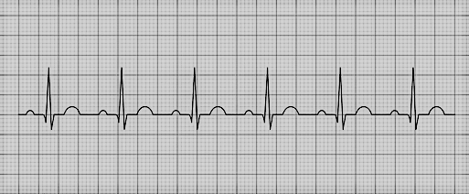
Fig 1: Normal Sinus Rhythm. Normal P- wave, QRS complex is well arranged and T- wave is also normal in nature. No any abnormalities found in this ECG. PR Interval, QRS Interval and QT Interval seem to be normal [12].

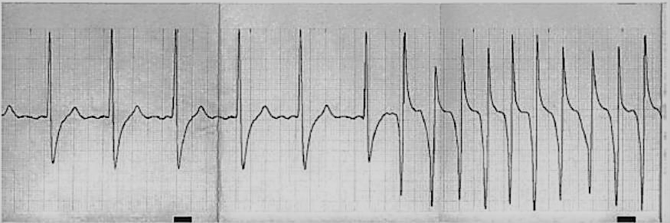
Fig 2: Monomorphic sudden-onset non-anger generated cardiac arrhythmia, [13].

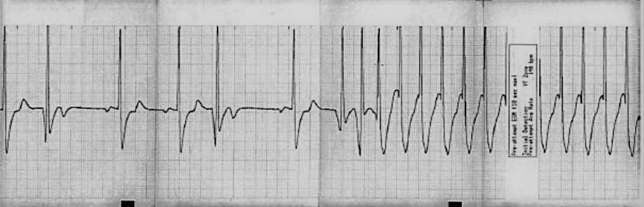
Fig 3: Monomorphic Premature Ventricular Contraction (PVC) initiated Pause - Dependent Cardiac Arrhythmia. (Anger-Triggered), [13].

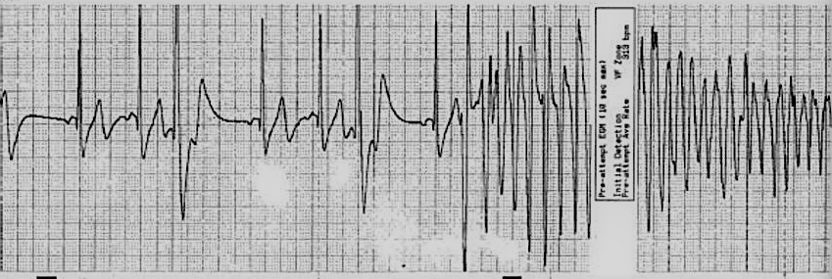
Fig 4: Polymorphic Premature Ventricular Contraction initiated Pause - Dependent anger-triggered cardiac arrhythmia, [13].

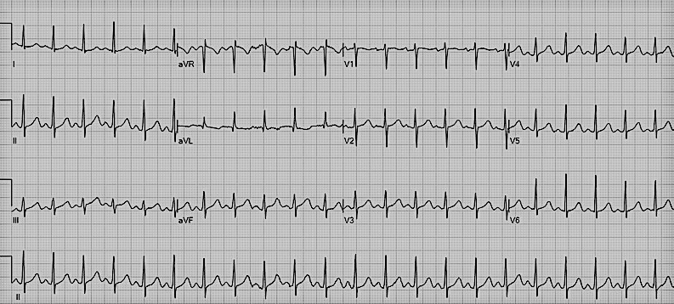
Fig 5: Sinus tachycardia with estimated approximate 132bpm [14].

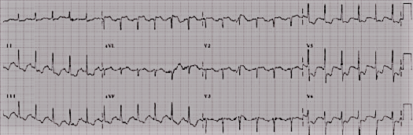
Fig 6: Anxiety induced ST wave depression [15].

Electrophysiological processes of stress-induced arrhythmia can be elucidated using signal processing methods. Toivonen et al [16] investigated QT wave variations under scientifically induced stress via controlled trial using human model of stress rather than doing animal study. To attain the result, randomly selected on-call medical house officers have been selected. The QT - intervals were contrasted to periods of physiological and psychological rest with identical heart rates (HR) during times of arousal owing to a page. They discovered QT- hysteresis during stressful situations, with prolonged QT than at rest, comparable QT hysteresis and it has also been reported during intensive exercise. [17] Overstatement of QT- hysteresis in reaction to physical exercise is hypothesized to be one of the main mechanisms driving sudden death in athletes, and it might also be a component in stress-related SCD.

By monitoring T-wave alternans (TWA) throughout an experimental laboratory psychological stress regimen, we looked straight at the contact of psychological distress and its clinically significant outcome on heterogenic effect of cardiac repolarization as a component of long-recognized factor to develop cardiac arrhythmogenesis. It is possible to induce psychological distress in the laboratory under the supervision of a practicing and experienced psychologist or psychiatrist by means of a number of maneuver or approaches, somewhat analogous to how we may create physical stress in a TET (Treadmill Exercise Test). These can include requiring the selected patient to execute mental arithmetic, just like serial number addition or subtraction of any three-digit figure within a particular time, or giving an oral/vocabulary related assignment amid an emotional setting/component including emotional contents in higher level. We use a stressor termed "rage recall" in our lab. Just like if they were addressing a buddy afterwards in the day, we also ask the participants to discuss about a current occasion that made them upset or furious.

In one clinical trial T- Wave alternans or commonly called TWA, T- Wave amplitude or t’amp, and T- Wave area (T area) was systematically calculated in the moment in time - regularity sphere of influence by using Interbeat middling procedure to analyze the influence of psychological pressure on trio-plane metrics of dissimilarity that can also be ascertained from another systematic monitoring method called holter monitoring technique: TWA, T amp and T area. [18] A psychological hassle modus operandi combining intellectual reckoning and ire evoke was used on around thirty-three individuals in the connection of implantable cardioverter defibrillators and a narration of different ventricular arrhythmias in this investigation. During mental stress, TWA rose from the 22uv as a baseline degree to till 29uv. Mental distress raised all additional indexes of heterogeneity as well. [19] (For better understanding refer figure 7, 8 and 9) during times of stress, Broad- Range repolarization inadequacy, that encompasses Non-Alternans periodicity, rose as well. [20] Mental stress was found to enhance TWA in a similar research also [21].

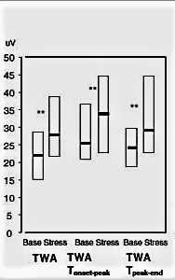

Fig 7: Repolarization changes due to mental stress/distruss. Block plots indicates median and interquartile ranges. TWA= T-wave alternans, [13].

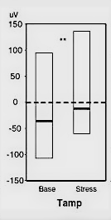
Fig 8: T-wave amplitude changes [13].

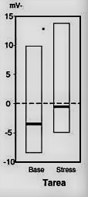
Fig 9: Tarea= T-wave area changes [13].

There are no recognized pathways via which emotional stress might enhance TWA. Kop and colleagues were capable to ascertain that the effect of rage on T- Wave alternans was distinct of ischemia by using concurrent SPECT-perfusion imaging. [22] TWA can be affected by increasing heart rate solely (for example, by atrial pacing), however there was a little rise in heart rate with mental stress in our research (as is typical with mental stress). We did notice a link between increases in TWA and catecholamines, implying a straight sympathetic action on cellular repolarization. Previous research has also demonstrated that sympathetic activity of body, additionally to the effects of heart rate, may enhance TWA. TWA is abolished by stellectomy and increased by stellate ganglion stimulation in experiments. [23] Intravenous beta-blockade [24] reduced the size of TWA in clinical investigations, and TWA caused by exercise is larger than that induced by atrial pacing at the same heart rate. [25].

The effect of rage on TWA in the lab predicted real-life arrhythmias. In a follow-up investigation of our anger and T Wave Alterens study, [26] we discovered that anger-induced T Wave Alterance was a powerful determinant of arrhythmia, well with risk of ICD-treated ventricular arrhythmia for those in the upper quartile of anger-induced in the laboratory being over 10 times higher than other subjects (Figure 7) After correcting for traditional arrhythmia predictors including ejection fraction, preceding acute arrhythmia, and broad QRS, anger-induced TWA stayed prognostic. Numerous research findings have also shown that TWA determine future arrhythmia, notably anyone using time-domain method of analysis, like the Modified Moving Average procedure, about which our Interbeat Average is similar [27], and a recent consensus result supports its use, scientific studies involving over 12,000 patients: "Overall, we believe that TWA examination should be considered if there is a concern of sensitivity to deadly cardiac arrhythmias." Furthermore, there is no compelling proof from interventional studies that it can be used to guide therapy at this time." [28] Time-domain approaches have the benefit of not requiring an elevated heart rate (as spectral methods do), allowing investigations to be conducted while on prescription beta-blockers. The predictive value of the test is dramatically reduced when beta-blockers are used [29]. This conclusion is consistent with the observations about the influence of autonomic variables on TWA: TWA testing performed in an autonomic state comparable to the patient's typical condition is more predictive of future outcome. Our investigation was hampered by its size, the fact that it only included males, and the fact that it used corrected arrhythmias as an endpoint at an age before evidence-based programming. The strong predictive value found here, though, provides an interesting prospect: experimental mental stress-induced TWA may be an even greater sensor of arrhythmia risk, as this approach captures the interplay of activator and substrate that can lead to arrhythmogenesis.
- Overview Of How ECG Varies Due to Significant Psychological Stress in The Atrium
Stressful stimuli have been linked to AF in small case studies. In two studies published in the year 1968 and 1999, [30, 31] two to thirty percent of AF occurrences were caused by "emotional or physical weariness," with particular cues identified as a family funeral or waking up to an alarm. [32] The first prospective research of emotional AF triggering was just published. [33] Ninety-five patients with sporadic AF finished an e-Diary inquiry of their emotions such as anger, anxiousness, despair, strain, and pleasure for the foregoing (proximal) thirty minutes, (Figure-7) moreover at the end of every date, abbreviation of patients emotions have been analyzed in the particular day. Emotions recorded on the e-Diary for the thirty minutes leading upto arterial fibrillations were analyzed to individuals who recorded cardiac rhythm during the last 24 hrs using Holter monitoring technique in order to make correlation in sinus rhythm. End-of-day emotion summaries for days before a day with AF were contrasted to end-of-day mood summaries for days leading up a day without AF in the same way. Forty participants reported a total of 228 symptomatic AF occurrences. On the e-Diary, there were one hundred and sixty nine episodes with proximal sensation reports, and approximately eleven thousand five hundred and sixty three psychological sentiment reports were identified all through Holter-long-established sinus rhythm, approximately one hundred and twelve end of day summation sentiment entries past time amid incidents of atrial fibrillation, plus approximately 14663 end of day summation sentiment findings proceeding days without AF. Sense of loss, worry, aggression, and stress all raised the risk of an AF event by 2-5 times. Pleasure reduced the incidence of AF by 85%. Rage and tension, as measured by end-of-day emotion summaries, both increases risk of AF the next day. (Fig.3).

The processes behind stress's arrhythomogenic impacts on AF are less well known. In most [34] but not all [35] investigations, sympathetic stimulation reduces repolarization as evaluated by the atrial effective refractory time in invasive tests. Furthermore, when paired with vagal impulses, sympathetic activation has a synergistic effect. [36]. The signal-averaged P wave may be used to quantify atria conduction noninvasively, and a lengthy SA – P period has been linked to recurrent AF. [37] Sympathetic stimulation with isoproterenol diminishes SA-P duration in the normal atrium; beta-blockers, on the other hand, impede conduction. Subsequent to beta blockade, atropine reduced SA- P period demonstrating that Vagal stimulation delayed conduction. [38] Furthermore, P- Wave duration determined since 24- hrs Holter surveillance is reduced during the day, indicating that variations in sympatho-vagal balance affect atrial conduction. [39].

We've focused on the impact of psychological distress in people with significant AF who have aberrant Atrial Conduction. [40] In one clinical research, approximately 97 patients who are suffering from AF and around 25 controlled volunteers were subjected to comparable mental stress assessment in the lab as stated afar. By and large, P- Wave conduction duration was greater than at its normal baseline also at some stage in aggression than in controls, although both groups' P-wave duration reduced with anger in a comparable manner. Furthermore, late potentials rose in AF patients but reduced in controls, as measured by RMS-40, meaning Root Mean Square Voltage of the last forty mille seconds and there were some negative correlations in between the shift in P – Wave duration as well as the variation in RMS-40 in AF patients. The electrophysiological processes behind this discovery have yet to be discovered. It is also likely that anger related organic autonomic alterations exacerbated the pre-existing diverseness of cardiac conduction in individuals with established AF base, case in point, by decreasing cardiac conduction periods in normally healthy tissues while leaving defective tissue unchanged, resulting in AF susceptibility.
- Mental Stress and Ventricular Arrhythmias
Investigations of population stresses have revealed that anger and other unpleasant emotions can cause unexpected mortality. Anger has been shown to cause ventricular arrhythmias in people with implanted defibrillators in clinical research. Arrhythmias are also made more vulnerable by long-term unpleasant emotions. Autonomic alterations, which modify repolarization, presumably increased in individuals having Sympathetic Denervation and which in return produce possibly fatal significant Polymorphic Ventricular Tachycardia are among the mechanisms relating rage and arrhythmias. In individuals with implanted cardioverter defibrillators, treatments that reduce emotional distress and the resulting autonomic reactions may be beneficial [Fig 10 and 11].

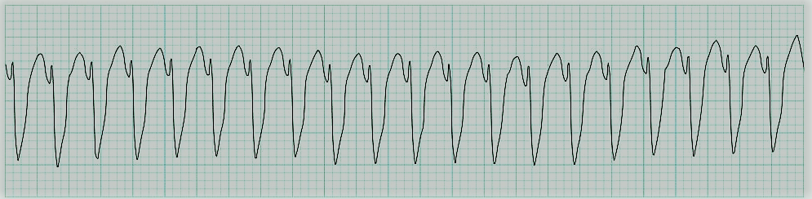
Fig 10: Monomorphic ventricular tachycardia (Regular and broad complex in nature) [41].

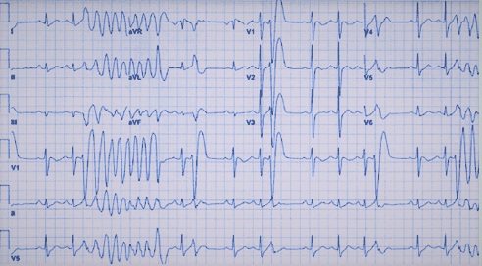
Fig 11: Intermittent polymorphic ventricular tachycardia [42].

- Significant Clinical Implications
Depending upon our own systematic clinical analysis and several other researchers’ discoveries that anxiety or any other significant mental stress may cause atrial or ventricular arrhythmias and in some extreme cases periodically changing pattern of both of this symptoms can be seen and it appears exceptionally prone that therapies focused at reducing mental strain or physiological impact of psychologically significant stress on the body, will reduce cardiac arrhythmia incidence in vulnerable individuals. The above-mentioned ECG indicators of psychological stress can act as submitters while also providing mechanistic information. We're testing if an eight-week stress management programme targeted for lowering depressing feeling will help people with ICDS have fewer arrhythmias. [43] This particular clinical study is also trying to test if tension decline technique can decrease the elevation of significant TWA associated with laboratory stress test. The result is also stated above in order to fully understand the mechanisms of action. Yoga and other complementary therapies have been demonstrated to reduce atrial and ventricular arrhythmia signs. To reduce stress-induced arrhythmias, more study is needed into both classic psycho-educational and complementary treatments.
- Summary
Both atrial and ventricular arrhythmias can be associated with stress. ECG stress profiles can give mechanistic insight as well as serve as surrogate endpoints in investigations looking into treatment options. However, there are a variety of methods for assessing repolarization as well as repolarization heterogeneity in the ventricle, there are less alternatives for studying atrial electrophysiology noninvasively, and that is an important subject for future studies.

References

[1] Lampert, R. (2016). Mental stress and ventricular arrhythmias. Current cardiology reports, 18(12), 1-7.
Google Scholar
[2] Critchley, H. D., Taggart, P., Sutton, P. M., Holdright, D. R., Batchvarov, V., Hnatkova, K., ... & Dolan, R. J. (2005). Mental stress and sudden cardiac death: asymmetric midbrain activity as a linking mechanism. Brain, 128(1), 75-85.
Google Scholar
[3] Taggart, P., Sutton, P., Redfern, C., Batchvarov, V. N., Hnatkova, K., Malik, M., & Joseph, A. (2005). The effect of mental stress on the non-dipolar components of the T wave: modulation by hypnosis. Psychosomatic medicine, 67(3), 376-383.
Google Scholar
[4] Johnson, B., & Francis, J. (2014). Stress and cardiac arrhythmias. Indian pacing and electrophysiology journal, 14(5), 230-239.
Google Scholar
[5] Jelinek, H. F., Spence, I., Cornforth, D. J., Tarvainen, M. P., & Russell, J. (2018). Depression and cardiac dysautonomia in eating disorders. Eating and Weight Disorders-Studies on Anorexia, Bulimia and Obesity, 23(3), 369-374.
Google Scholar
[6] Yang, A. C., Hong, C. J., & Tsai, S. J. (2010). Heart rate variability in psychiatric disorders. Taiwanese Journal of Psychiatry (Taipei), 24(2), 99-109.
Google Scholar
[7] Goldstein, D. S. (1995). Stress, catecholamines, and cardiovascular disease, Oxford University Press, 36(4), 412-418.
Google Scholar
[8] Meisel, S. R., Dayan, K. I., Pauzner, H., Chetboun, I., Arbel, Y., David, D., & Kutz, I. (1991). Effect of Iraqi missile war on incidence of acute myocardial infarction and sudden death in Israeli civilians. The Lancet, 338(68), 660-661.
Google Scholar
[9] Bergovec, M., Mihatov, S., Prpić, H., Rogan, S., Batarelo, V., & Sjerobabski, V. (1992). Acute myocardial infarction among civilians in Zagreb city area. Lancet (London, England), 339(87), 303-309.
Google Scholar
[10] Leor, J., Poole, W. K., & Kloner, R. A. (1996). Sudden cardiac death triggered by an earthquake. New England Journal of Medicine, 334(7), 413-419.
Google Scholar
[11] Steinberg, J. S., Arshad, A., Kowalski, M., Kukar, A., Suma, V., Vloka, M., ... & Rozanski, A. (2004). Increased incidence of life-threatening ventricular arrhythmias in implantable defibrillator patients after the World Trade Center attack. Journal of the American College of Cardiology, 44(6), 1261-1264.
Google Scholar
[12] Retrieved from Google Image. Https://www.shutterstock.com/image-vector/electrocardiogram-show-normal-heart-beat-line-1688917729

[13] Stopper, M., Joska, T., Burg, M. M., Batsford, W. P., mcpherson, C. A., Jain, D., & Lampert, R. (2007). Electrophysiologic characteristics of anger-triggered arrhythmias. Heart Rhythm, 4(3), 268-273.
Google Scholar
[14] Retrieved from https://commons.wikimedia.org/wiki/File:ECG_Sinus_Tachycardia_132_bpm.jpg
[15] Retrieved from https://thoracickey.com/emotion-and-the-ecg/
[16] Lampert, R., Joska, T., Burg, M. M., Batsford, W. P., mcpherson, C. A., & Jain, D. (2002). Emotional and physical precipitants of ventricular arrhythmia. Circulation, 106(14), 1800-1805.
Google Scholar
[17] Dimsdale, J. E., Pierce, C., Schoenfeld, D., Brown, A., Zusman, R., & Graham, R. (1986). Suppressed anger and blood pressure: the effects of race, sex, social class, obesity, and age. Psychosomatic medicine.1(2), 253-268.
Google Scholar
[18] Toivonen, L., Helenius, K., & Viitasalo, M. (1997). Electrocardiographic repolarization during stress from awakening on alarm call. Journal of the American College of Cardiology, 30(3), 774-779.
Google Scholar
[19] Sarma, J. S., Venkataraman, K., Samant, D. R., & Gadgil, U. (1987). Hysteresis in the human RR‐QT relationship during exercise and recovery. Pacing and Clinical Electrophysiology, 10(3), 485-491.
Google Scholar
[20] Shusterman, V., & Goldberg, A. (2004). Tracking repolarization dynamics in real-life data. Journal of electrocardiology, 37(1), 180-186.
Google Scholar
[21] Lampert, R., Shusterman, V., Burg, M. M., Lee, F. A., Earley, C., Goldberg, A., ... & Soufer, R. (2005). Effects of psychologic stress on repolarization and relationship to autonomic and hemodynamic factors. Journal of cardiovascular electrophysiology, 16(4), 372-377.
Google Scholar
[22] Abisse, S. S., Lampert, R., Burg, M., Soufer, R., & Shusterman, V. (2011). Cardiac repolarization instability during psychological stress in patients with ventricular arrhythmias. Journal of electrocardiology, 44(6), 678-683.
Google Scholar
[23] Kop, W. J., Krantz, D. S., Nearing, B. D., Gottdiener, J. S., Quigley, J. F., O’Callahan, M., ... & Verrier, R. L. (2004). Effects of acute mental stress and exercise on T-wave alternans in patients with implantable cardioverter defibrillators and controls. Circulation, 109(15), 1864-1869.
Google Scholar
[24] Nearing, B. D., Huang, A. H., & Verrier, R. L. (1991). Dynamic tracking of cardiac vulnerability by complex demodulation of the T wave. Science, 252(504), 437-440.
Google Scholar
[25] Rashba, E. J., Cooklin, M., macmurdy, K., Kavesh, N., Kirk, M., Sarang, S., ... & Gold, M. R. (2002). Effects of selective autonomic blockade on T-wave alternans in humans. Circulation, 105(7), 837-842.
Google Scholar
[26] Hohnloser, S. H., Klingenheben, T., Zabel, M., LI, Y. G., Albrecht, P., & Cohen, R. J. (1997). T wave alternans during exercise and atrial pacing in humans. Journal of cardiovascular electrophysiology, 8(9), 987-993.
Google Scholar
[27] Lampert, R., Shusterman, V., Burg, M., mcpherson, C., Batsford, W., Goldberg, A., & Soufer, R. (2009). Anger-induced T-wave alternans predicts future ventricular arrhythmias in patients with implantable cardioverter-defibrillators. Journal of the American College of Cardiology, 53(9), 774-778.
Google Scholar
[28] Verrier, R. L., Klingenheben, T., Malik, M., El-Sherif, N., Exner, D. V., Hohnloser, S. H.,& Rosenbaum, D. S. (2011). Microvolt T-wave alternans: physiological basis, methods of measurement, and clinical utility—consensus guideline by International Society for Holter and Noninvasive Electrocardiology. Journal of the American College of Cardiology, 58(13), 1309-1324.
Google Scholar
[29] Peter, R. H., Gracey, J. G., & Beach, T. B. (1968). A clinical profile of idiopathic atrial fibrillation: A functional disorder of atrial rhythm. Annals of internal medicine, 68(6), 1288-1295.
Google Scholar
[30] Lévy, S., Maarek, M., Coumel, P., Guize, L., Lekieffre, J., Medvedowsky, J. L., & Sebaoun, A. (1999). Characterization of different subsets of atrial fibrillation in general practice in France: the ALFA study. Circulation, 99(23), 3028-3035.
Google Scholar
[31] Houghton, J. L., Devlin, C. W., Besson III, W. T., Crawford, W., Fincher, R. M. E., Flowers, N. C., & Frank, M. J. (1990). Possible triggering of paroxysmal atrial fibrillation in normal hearts by psychological stressors: a report of two cases. The American journal of the medical sciences, 300(4), 234-236.
Google Scholar
[32] Lampert, R., Jamner, L., Burg, M., Dziura, J., Brandt, C., Liu, H., ... & Soufer, R. (2014). Triggering of symptomatic atrial fibrillation by negative emotion. Journal of the American College of Cardiology, 64(14), 1533-1534.
Google Scholar
[33] Liu, L. I. L. I., & Nattel, S. T. A. N. L. E. Y. (1997). Differing sympathetic and vagal effects on atrial fibrillation in dogs: role of refractoriness heterogeneity. American Journal of Physiology-Heart and Circulatory Physiology, 273(2), 805-816.
Google Scholar
[34] Zipes, D. P., Mihalick, M. J., & Robbins, G. T. (1974). Effects of selective vagal and stellate ganglion stimulation on atrial refractoriness. Cardiovascular Research, 8(5), 647-655.
Google Scholar
[35] Raitt, M. H., Ingram, K. D., & Thurman, S. M. (2000). Signal‐averaged P wave duration predicts early recurrence of atrial fibrillation after cardioversion. Pacing and Clinical Electrophysiology, 23(2), 259-265.
Google Scholar
[36] Cheema, A. N., Ahmed, M. W., Kadish, A. H., & Goldberger, J. J. (1995). Effects of autonomic stimulation and blockade on signal-averaged P wave duration. Journal of the American College of Cardiology, 26(2), 497-502.
Google Scholar
[37] Dilaveris, P. E., Färbom, P., Batchvarov, V., Ghuran, A., & Malik, M. (2001). Circadian behavior of P‐wave duration, P‐wave area, and PR interval in healthy subjects. Annals of noninvasive electrocardiology, 6(2), 92-97.
Google Scholar
[38] Guidera, S. A., & Steinberg, J. S. (1993). The signal-averaged P wave duration: a rapid and noninvasive marker of risk of atrial fibrillation. Journal of the American College of Cardiology, 21(7), 1645-1651.
Google Scholar
[39] Donahue, R. G., Lampert, R., Dornelas, E., Clemow, L., & Burg, M. M. (2010). Rationale and design of a randomized clinical trial comparing stress reduction treatment to usual cardiac care: The Reducing Vulnerability to ICD Shock-Treated Ventricular Arrhythmias (RISTA) trial. Psychosomatic medicine, 72(2), 172-180.
Google Scholar
[40] Lakkireddy, D., Atkins, D., Pillarisetti, J., Ryschon, K., Bommana, S., Drisko, J., ... & Dawn, B. (2013). Effect of yoga on arrhythmia burden, anxiety, depression, and quality of life in paroxysmal atrial fibrillation: the YOGA My Heart Study. Journal of the American College of Cardiology, 61(11), 1177-1182.
Google Scholar
[41] Retrieved from https://litfl.com/ventricular-tachycardia-monomorphic-ecg-library/

[42] Retrieved from https://www.consultant360.com/content/ecg-changes-polymorphic-ventricular-tachycardia

[43] Toise, S. C., Sears, S. F., Schoenfeld, M. H., Blitzer, M. L., Marieb, M. A., Drury, J. H., ... & Donohue, T. J. (2014). Psychosocial and cardiac outcomes of yoga for ICD patients: a randomized clinical control trial. Pacing and Clinical Electrophysiology, 37(1), 48-62.
Google Scholar

*****

